**Assignment 7**

CODE:

ArithmeticOperations.java

package com.calc;

import java.io.*;

import javax.servlet.*;

import javax.servlet.annotation.WebServlet;

import javax.servlet.http.*;

@WebServlet("/ArithmeticOperations")

public class ArithmeticOperations extends HttpServlet {

protected void doPost(HttpServletRequest request, HttpServletResponse response)

throws ServletException, IOException {

response.setContentType("text/html");

PrintWriter pw = response.getWriter();

try {

int no1 = Integer.parseInt(request.getParameter("No1"));

int no2 = Integer.parseInt(request.getParameter("No2"));

String operation = request.getParameter("operation");

pw.println("<html><head><title>Result</title></head><body>");

pw.println("<h2>Result:</h2>");

switch (operation) {

case "add":

pw.println("Addition: " + (no1 + no2));

break;

case "sub":

pw.println("Subtraction: " + (no1 - no2));

break;

case "mul":

pw.println("Multiplication: " + (no1 * no2));

break;

case "div":

if (no2 != 0)

pw.println("Division: " + (no1 / no2));

else

pw.println("Division: Cannot divide by zero");

break;

default:

pw.println("Invalid operation selected.");

}

pw.println("</body></html>");

} catch (NumberFormatException e) {

pw.println("<html><body><h2>Error: Please enter valid numbers!</h2></body></html>");

}

}

}

index.html

<!DOCTYPE html>

<html>

<head><title>Arithmetic Operations</title></head>

<body>

<h2>Arithmetic Operation</h2>

<form method="post" action="ArithmeticOperations">

Number 1: <input type="text" name="No1"><br><br>

Number 2: <input type="text" name="No2"><br><br>

Select Operation:<br>

<input type="radio" name="operation" value="add" checked> Addition<br>

<input type="radio" name="operation" value="sub"> Subtraction<br>

<input type="radio" name="operation" value="mul"> Multiplication<br>

<input type="radio" name="operation" value="div"> Division<br><br>

<input type="submit" value="Calculate">

</form>

</body>

</html>

OUTPUT:

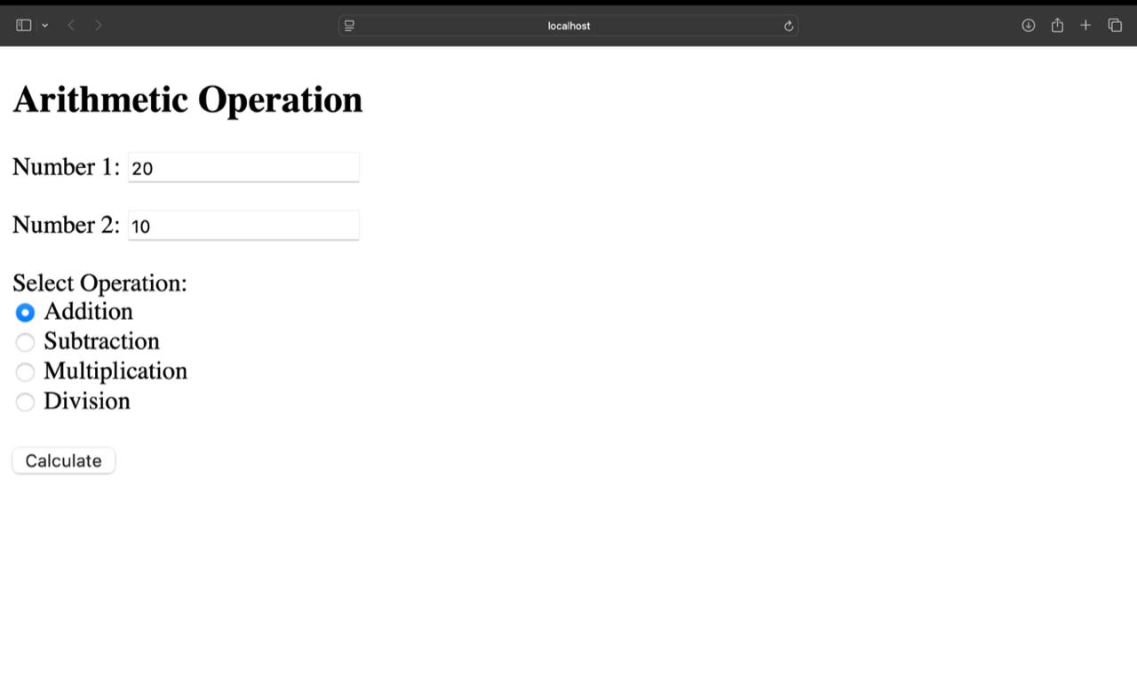

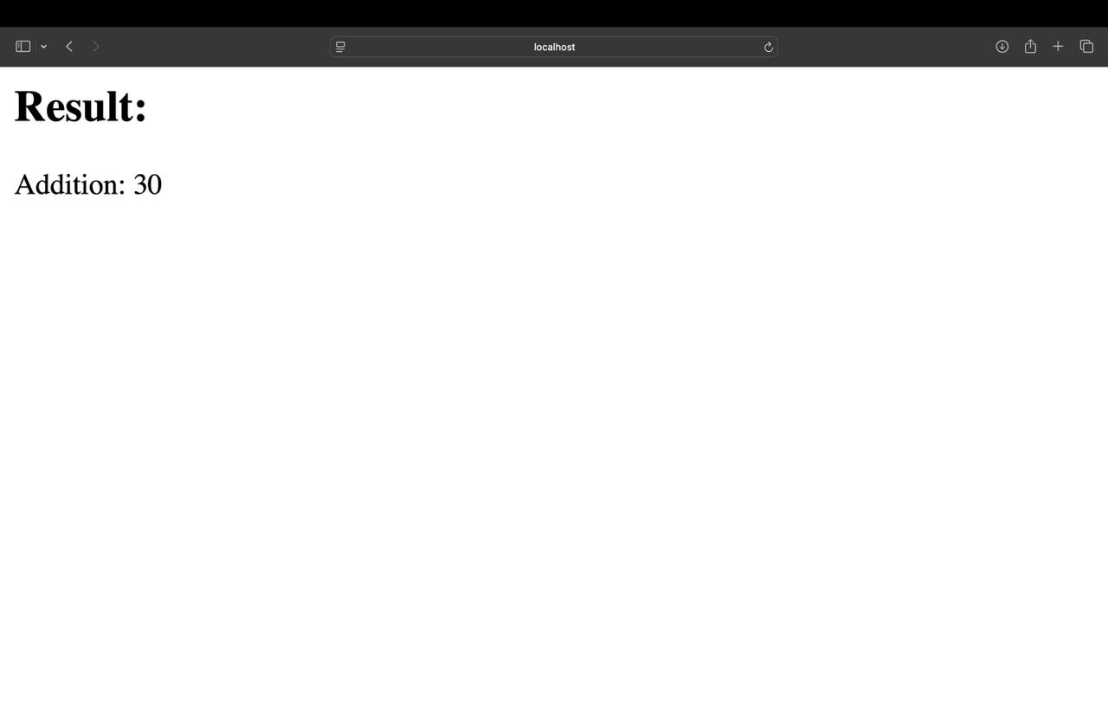

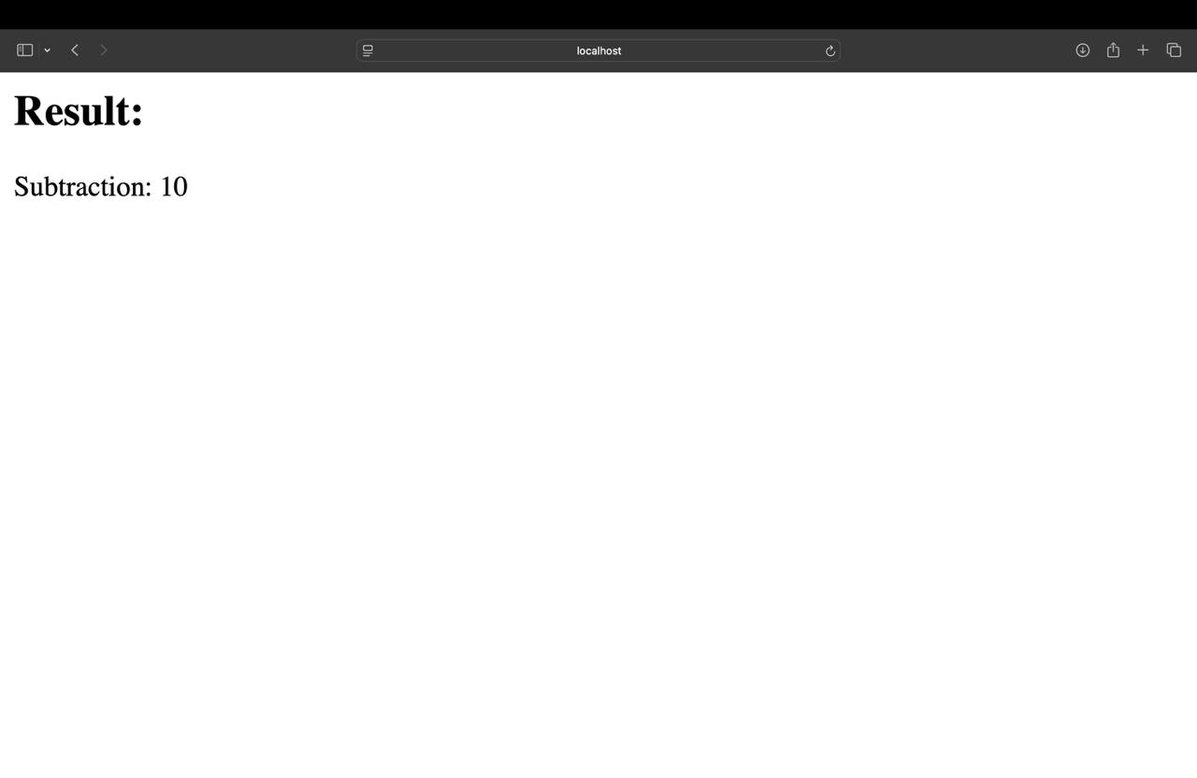

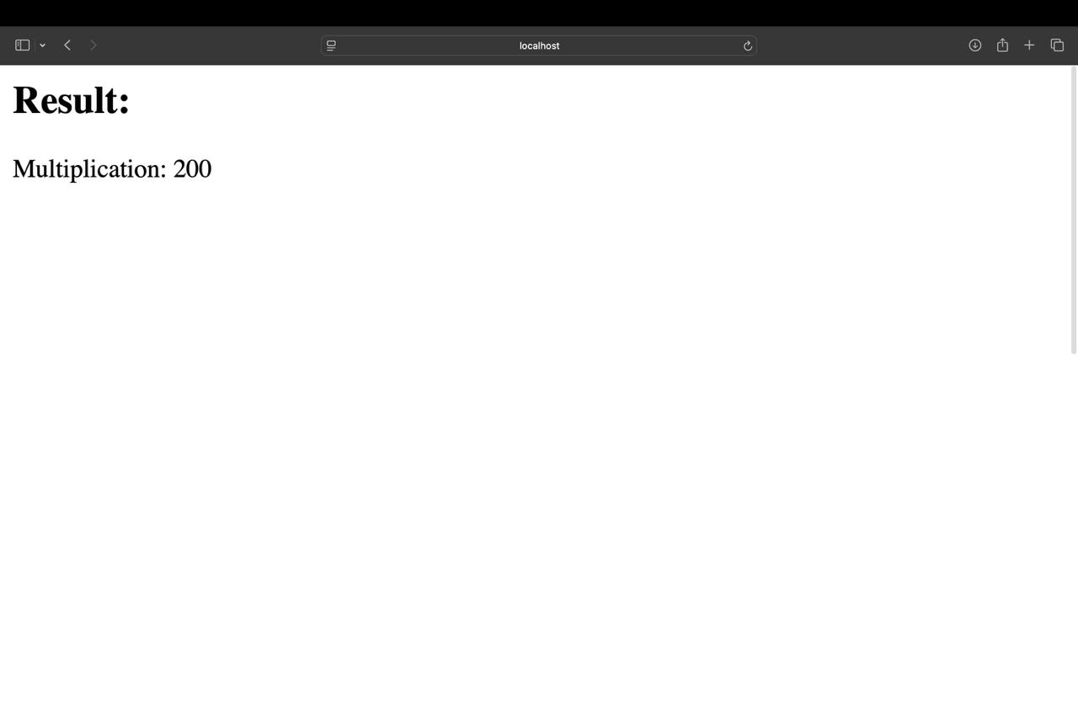

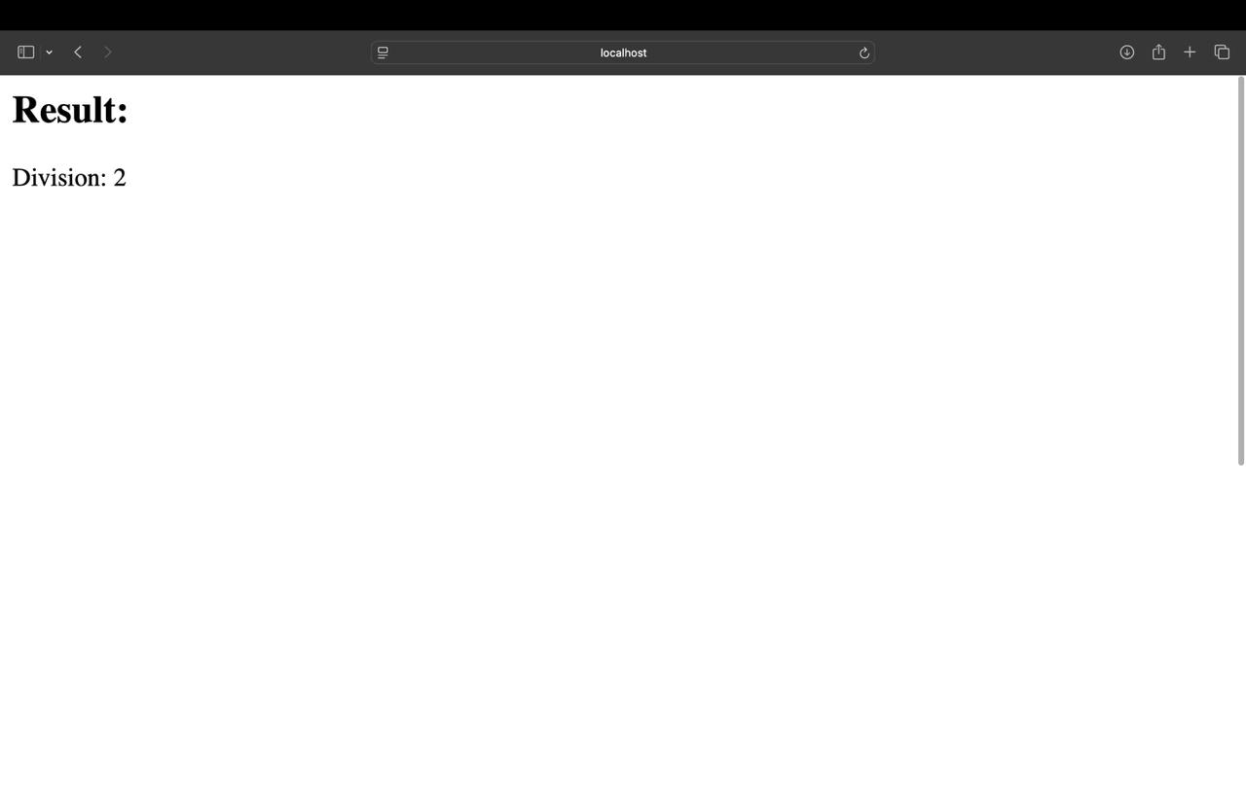

CalculatorWSClient.java

import java.io.*;

import java.net.*;

import java.util.Scanner;

public class CalculatorWSClient {

public static void main(String[] args) {

Scanner scanner = new Scanner(System.in);

// Accept input from user

System.out.print("Enter first number: ");

int num1 = scanner.nextInt();

System.out.print("Enter second number: ");

int num2 = scanner.nextInt();

System.out.print("Enter operation (add, sub, mul, div): ");

String operation = scanner.next();

try {

// Construct the URL for the POST request

String serviceUrl = "http://localhost:8080/CalculatorWSApplication/ArithmeticOperations";

// Establish the connection

URL url = new URL(serviceUrl);

HttpURLConnection conn = (HttpURLConnection) url.openConnection();

conn.setRequestMethod("POST"); // Use POST method

conn.setDoOutput(true); // Allow sending data in the request body

// Prepare the data to send in the body of the POST request

String data = "No1=" + num1 + "&No2=" + num2 + "&operation=" + operation;

// Send data

try (OutputStream os = conn.getOutputStream()) {

byte[] input = data.getBytes("utf-8");

os.write(input, 0, input.length);

}

// Get the input stream and read the response

BufferedReader in = new BufferedReader(new InputStreamReader(conn.getInputStream()));

String inputLine;

StringBuilder response = new StringBuilder();

while ((inputLine = in.readLine()) != null) {

response.append(inputLine);

}

in.close();

// Extract the result from the HTML response

String result = response.toString();

String operationResult = result.split("<h2>Result:</h2>")[1].split("</body>")[0].replaceAll("<[^>]*>", "").trim();

// Print the result

System.out.println("Result: " + operationResult);

} catch (Exception e) {

e.printStackTrace();

}

}

}

OUTPUT:

